**Attrition Assignment**

**Step1 – Launching**

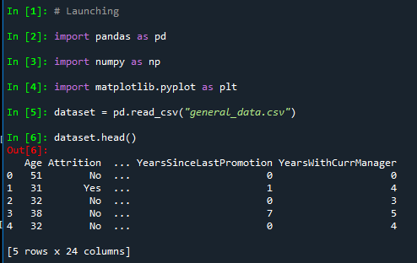

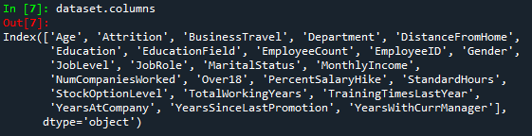

**Step 2 - Data Treatment:**

#Checking null values in the table

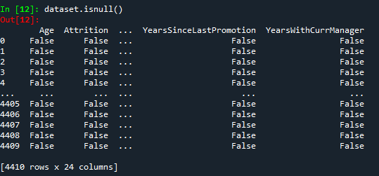

#Checking if duplicated values in the dataset

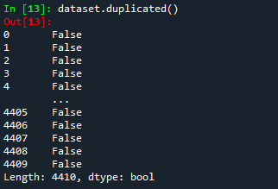

**Step 3 – Univariate Analysis:**

# To describe the dataset

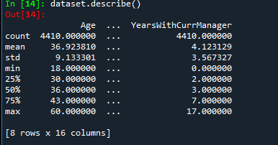

# To find mean for each column

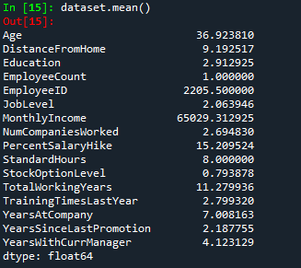

# To find skewness for each column values

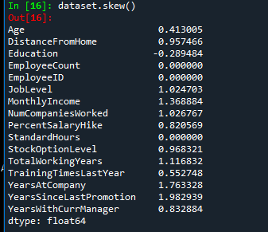

# To find kurtosis for each column values

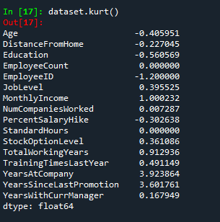

**Inference from the analysis:**

1. All the above variables show positive skewness; while Age & Mean_distance_from_home are leptokurtic and all other variables are platykurtic.
2. The Mean_Monthly_Income’s IQR is at 54K suggesting company wide attrition across all income bands
3. Mean age forms a near normal distribution with 13 years of IQR

**Outliners:**

There’s no regression found while plotting Age, MonthlyIncome, TotalWorkingYears , YearsAtCompany, etc., on a scatter plot.

**plt.boxplot(dataset.Age)**

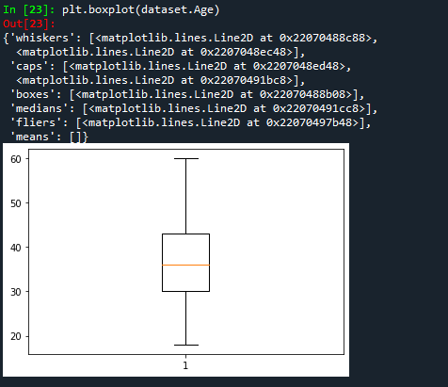

**plt.boxplot(dataset.MonthlyIncome)**

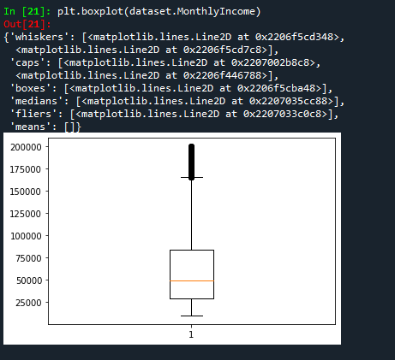

**Years at company is also Right Skewed with several outliers observed.**